LED Array Effect use For Loop Iteration

Often you want to iterate over a series of pins and do something to each one. For instance, this example blinks 6 LEDsattached to the Arduino or Genuino by using a [for()](https://www.arduino.cc/en/Reference/For) loop to cycle back and forth through digital pins 2-7. The LEDS are turned on and off, in sequence, by using both the [digitalWrite()](https://www.arduino.cc/en/Reference/DigitalWrite) and [delay()](https://www.arduino.cc/en/Reference/Delay) functions .

We also call this example "[Knight Rider](http://en.wikipedia.org/wiki/KITT)".

Hardware Required

* Arduino or Genuino Board
* 6 220 ohm resistors
* 6 LEDs
* hook-up wires
* breadboard

Circuit

Connect six LEDS, with 220 ohm resistors in series, to digital pins 2-7 on your Arduino.

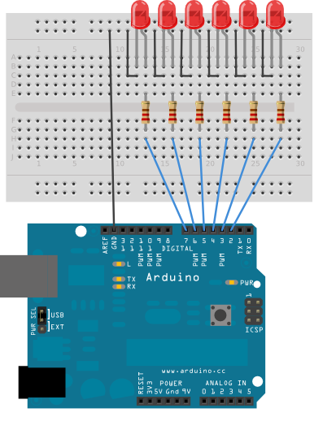

Schematic:

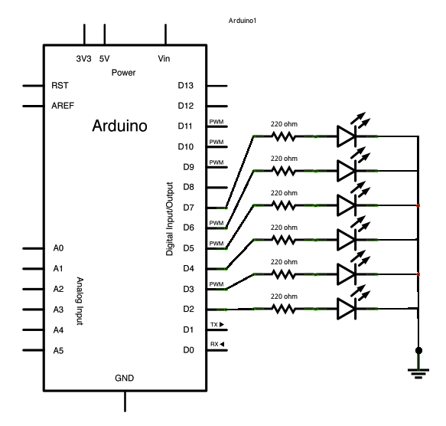

Code

The code below begins by utilizing a for() loop to assign digital pins 2-7 as outputs for the 6 LEDs used.

In the main loop of the code, two for() loops are used to loop incrementally, stepping through the LEDs, one by one, from pin 2 to pin seven. Once pin 7 is lit, the process reverses, stepping back down through each LED.